Analyzing the Predictive Performance of Time Series Models on Brent Oil Prices

 | Sanly  Statistics Department,  School of Computer Science  Bina Nusantara University  Jakarta, Indonesia  sanly@binus.ac.id | Zahra Annisa Afandi  Statistics Department,  School of Computer Science  Bina Nusantara University  Jakarta, Indonesia  zahra.afandi@binus.ac.id

Abstract—Brent crude oil is a critical global energy supply, with price fluctuations that significantly influence economic activities, financial markets, and policy decisions. The inherent complexity and dynamic behavior of oil price movements make the selection of an effective forecasting model particularly challenging. This study compares the predictive performance of several time series forecasting methods, including Naïve Trend, Double Moving Average (DMA), Double Exponential Smoothing (DES), Time Series Regression, Autoregressive Integrated Moving Average (ARIMA), Multi-Layer Perceptron (MLP), Long Short-Term Memory (LSTM), and Gated Recurrent Unit (GRU), for forecasting Brent crude oil prices. Daily closing price data for Brent crude oil were obtained from Investing.com, spanning October 2023 to April 2026, resulting in 660 observations. To evaluate the models, the dataset was partitioned into training and testing sets using an 80:20 ratio, with performance measured via RMSE, MAE, and MAPE. The findings indicate that machine learning and deep learning techniques generally outperform conventional statistical methods in terms of forecasting precision. Notably, the two-layer GRU network (configured with 128 and 64 hidden units) delivered the top performance, registering the lowest error rates with an RMSE of 3.704, an MAE of 2.325, and a MAPE of 2.70%. These outcomes underscore the GRU model's proficiency in modeling the nonlinear dynamics and temporal structures inherent in Brent crude oil prices, making it a highly viable approach for commodity price prediction.
Keywords—Brent crude oil, Machine Learning, Statistical Forecasting, Time Series Forecasting

Introduction
Petroleum, commonly referred to as crude oil, consists of a complex mixture of hydrocarbons that are processed into various types of fuel [1]. As a foundational pillar of the global energy mix, fluctuations in its price exert a profound influence on worldwide economic stability [2]. Global crude oil benchmarks are primarily categorized into two major types: Brent and West Texas Intermediate (WTI) [3]. Among these, Brent crude oil prices serve as a critical global indicator due to their high responsiveness to geopolitical shifts, financial market volatility, and macroeconomic policies [4]. Due to its powerful role in the global economy, understanding and forecasting Brent oil price movements has become an important research subject for academics, investors and governments [5]. Accurate oil price forecasting is difficult because prices are shaped by a volatile mix of factors: global economic conditions, market speculation, extreme events, political instability, and technological trends. Crucially, the weight and influence of each variable shift over time [6].
Consequently, forecasting oil prices has emerged as a critical and highly challenging domain within predictive research, notwithstanding the availability of diverse forecasting methodologies [7]. A prominent classical example is the Auto Regressive Integrated Moving Average (ARIMA) model, a parsimonious approach widely favored for its efficiency in capturing linear trends in data [8]. However, ARIMA often struggles when confronted with non-linear, highly volatile, and non-stationary data structures [9].
o address these limitations, machine learning (ML) frameworks including Multi-Layer Perceptron (MLP), Long Short-Term Memory (LSTM), and Gated Recurrent Unit (GRU) have gained significant traction for demand and price forecasting [7]. Given the inherent complexity, volatility, and uncertainty of economic time series, there is a pressing need for more precise architectures capable of mapping intricate patterns. This makes ML approaches a superior alternative to traditional statistical models like ARIMA and Exponential Smoothing (ETS) [10]. Within this paradigm, MLPs utilize densely connected layers and rely on supervised learning frameworks to generate predictions [10]. Another machine learning model such as Long Short-Term Memory (LSTM) and Gated Recurrent Units (GRUs are two types of neural network algorithms that are appropriate for time series analysis considering how algorithms handle the difficulty of a series and input dependency parameter [11] [12].
Although several studies have examined the forecasting of brent oil prices using statistical [13] [14] and machine learning approaches [1] [8] [15] [16] or using both of them [2] [17], the findings regarding their relative predictive performance remain mixed. While some studies report superior forecasting accuracy from advanced machine learning and deep learning models, others suggest that traditional statistical methods remain competitive under certain forecasting conditions. These inconsistent findings indicate that forecasting performance is highly dependent on preparation of the input data [18], forecasting horizon [19], and overall evaluation setup [20]. Consequently, it remains unclear whether increasingly complex forecasting models consistently provide meaningful improvements in predictive accuracy over simpler approaches.
To address this issue, the present study evaluates and compares diverse forecasting methodologies spanning both statistical and machine learning paradigms. Specifically, this research assesses the predictive performance of Naïve Trend, Double Moving Average (DMA), Double Exponential Smoothing (DES), ARIMA, Multilayer Perceptron (MLP), Long Short-Term Memory (LSTM), and Gated Recurrent Unit (GRU) models utilizing historical Brent crude oil price data. To rigorously measure the quality of these predictive frameworks, standard performance indicators—namely Mean Absolute Error (MAE), Mean Absolute Percentage Error (MAPE), and Root Mean Square Error (RMSE)—were employed [21].
Driven by these objectives, this study aims to resolve the following research questions:
RQ1: What are the historical characteristics and temporal patterns of Brent crude oil prices during the observation period?
RQ2: How does the predictive performance of Naïve Trend, DMA, DES, ARIMA, MLP, LSTM, and GRU models compare when forecasting Brent crude oil prices?
RQ3: Does increased model complexity lead to superior forecasting accuracy in Brent crude oil price prediction?
The study hypothesizes that models capable of learning nonlinear relationships and long-term temporal dependencies, particularly LSTM and GRU, will generally achieve higher forecasting accuracy than traditional statistical methods. However, it is also expected that the performance differences may vary depending on the characteristics of the Brent crude oil price series. By systematically comparing forecasting methods from different methodological paradigms, this research contributes to the growing literature on commodity price forecasting and provides practical insights into the selection of appropriate forecasting models for energy market applications.

Related Works
Prior to executing this study, a comprehensive literature review was undertaken to analyze previous research centered on crude oil price forecasting. This review aimed to identify existing gaps and challenges in the literature, serving as a foundational baseline for selecting the methodologies used in this research.
For instance, Iftikhar et. al., (2023) [6] introduced a hybrid forecasting framework for Brent crude oil prices that decomposes the original price series into a long-term nonlinear trend and a stochastic residual component using the Hodrick–Prescott filter. They subsequently utilized Autoregressive (AR), ARIMA, Nonparametric Autoregressive (NPAR), and Neural Network Autoregressive (NNA) models to forecast these distinct components. Evaluating daily data from January 2013 to December 2022, their hybrid approach demonstrated enhanced predictive accuracy across multiple metrics, including RMSPE, MAPE, MAE, RMSE, and the correlation coefficient. However, their scope was restricted to combinations of ARIMA-variants and basic neural networks, leaving advanced deep learning architectures like LSTM and GRU unexplored.
Regarding traditional time series methodologies, As’ad et al. (2023) [13] utilized Holt’s Double Exponential Smoothing model to predict crude oil prices, noting its effectiveness in tracking trend patterns with satisfactory accuracy. In a similar vein, Gampar et al. (2024) [14] c evaluated Holt’s Double Exponential Smoothing against ARIMA to forecast Indonesian oil and gas production, concluding that both models remain highly relevant due to their simplicity and interpretability. Nonetheless, these studies relied strictly on statistical frameworks and did not investigate whether advanced machine learning techniques could further yield predictive improvements..Nevertheless, these studies focused exclusively on statistical approaches and did not investigate whether more advanced machine learning models could provide additional predictive improvements.
The increasing availability of computational resources has encouraged the adoption of deep learning techniques for Brent crude oil forecasting. Daneshvar et al. (2022) [15] developed several deep neural network architectures to predict Brent crude oil prices and reported that deep learning models were capable of learning complex nonlinear relationships embedded in oil price movements. Their results suggested that neural-network-based approaches can serve as promising alternatives to conventional statistical methods, particularly when dealing with highly volatile market conditions. However, the study concentrated on deep neural network architectures without comparing them against benchmark forecasting models such as Naïve Trend, Double Moving Average, or Double Exponential Smoothing.
Further developments in recurrent neural networks have led to the application of Gated Recurrent Unit (GRU) architectures in oil price forecasting. Alruqimi et. al., (2024) [16] introduced an Ensemble Multi-Scenario Bi-GRU Network for multi-step Brent oil price forecasting. Their model successfully improved forecasting accuracy by combining information from multiple forecasting scenarios and leveraging bidirectional learning mechanisms. The results highlighted the potential of GRU-based architectures for capturing complex temporal dynamics in Brent oil prices. Nevertheless, the study focused on a highly specialized deep learning framework and did not examine how its performance compared with simpler forecasting approaches.
Amelia et. al., (2025) [1] proposed a forecasting framework that integrated LSTM and GRU feature extractors with machine learning regressors. By combining deep learning-based feature extraction and machine learning prediction models, the study achieved promising forecasting performance for crude oil prices. Their findings suggested that hybrid architectures can effectively exploit the strengths of different modeling paradigms. However, the increasing complexity of such models raises practical concerns regarding computational cost, model interpretability, and implementation requirements.
Comparative forecasting studies have also emerged in recent years. Brown et al. (2024) [17] conducted a comparative analysis between LSTM and traditional time series forecasting models on oil price data. Their results indicated that model performance varied across forecasting scenarios, suggesting that no single approach consistently outperformed all alternatives. Likewise, Schmid et al. (2025) [8] compared statistical and machine learning forecasting methods across multiple time series datasets and found that the superiority of a forecasting method often depended on data characteristics and evaluation settings. Although the study was not specifically focused on Brent crude oil prices, its findings reinforced the importance of evaluating forecasting methods under a consistent experimental framework.
In addition to forecasting methodologies, Krulicky et al. (2024) [2] examined the broader dynamics of Brent crude oil prices by analyzing factors influencing price fluctuations and long-term market trends. Their work highlighted the complexity of Brent oil markets and emphasized the challenges associated with accurately modeling and forecasting oil price behavior.
Overall, these studies demonstrate Brent crude oil forecasting using a variety of approaches, from traditional statistical approaches to more sophisticated machine learning. However, existing research is limited in its use of forecasting techniques or only compares models within similar methodological categories. Consequently, there is insufficient evidence to demonstrate how benchmark methods, statistical models, and machine learning approaches perform when evaluated simultaneously using the same Brent crude oil dataset and identical evaluation criteria. This limitation motivates this study, which compares Naive Trend, DMA, DES, ARIMA, MLP, LSTM, and GRU models within a unified forecasting framework to provide a more comprehensive assessment of their predictive performance.

Data and Methodology

Data Description
This study utilizes secondary data comprising historical Brent crude oil prices obtained from Investing.com [22]. The comprehensive dataset records the date, daily price metrics (open, high, low, and close), trading volume, and daily percentage change. For the predictive modeling in this research, only the date and closing price variables were extracted. The dataset spans a three-year period from October 2023 to April 2026, encompassing a total of 660 observations.

Stationarity Testing
Stationarity is an important property for many time series forecasting models, for example ARIMA [23]. In this study, stationarity was evaluated based on variance and mean as part of the model development process.

Stationarity Testing to Variance
Stationarity to variance was evaluated using the power transformation approach. The transformation can be expressed as described in Eq. (1) [14].
$$E\left(Y_{t}\right)= E{\left(Y_{t}-μ\right)}^{2}=σ^{2}$$ | (1)
The hypothesis states of the stationarity testing to variance are:
$H_{0}$: Data are stationary to variance
$H_{1}:$ Data are not stationary to variance
The data are considered stationary to variance when the p-value is greater than the significance level. If the data are not stationary to variance, a transformation should be applied.

Stationarity Testing to Mean
Stationarity to mean was performed using a unit root test developed by Dickey-Fuller, or better known as the Augmented Dickey-Fuller test [24]. The formula is described in Eq. 2.
$$Var\left(Y_{t}\right)=σ^{2}$$ | (2)
The hypothesis states of the stationarity testing to variance are
$H_{0}$: Data are not stationary to mean
$H_{1}:$ Data are stationary to mean

The data are considered stationary to mean when the p-value is less than the significance level. If the data are not stationary to mean, this shows one way to make a non-stationary time series stationary, compute the differences between consecutive observations also known as differencing as shown in Eq.3 [25].
$$Y_{t}^{'}=Y_{t}+Y_{t-1}$$ | (3)
Where $Y_{t}^{'}$ is the first-order differenced value at time $t$, $Y_{t}$ is the original value at time $t$, and $Y_{t-1}$ is the original value at time $t-1$.

Forecasting Models

Naïve Trend
The Naive Method is a very simple forecasting method, often used as a comparison due to its ease in obtaining forecast results [26]. The Naïve method in data trend can be expressed using the following forecasting equations in Eq. 5.
$${\hat{Y}}_{t+1}=Y_{t}+\left(Y_{t}-Y_{t-1}\right)$$ | (5)

$${\hat{Y}}_{t+1}= \frac{Y_{t}}{Y_{t-1}}$$ | (6)
Where ${\hat{Y}}_{t+1}$ is the forecast value for period $t+1$, $Y_{t}$ is the actual value at period $t$, and $Y_{t-1}$ is the actual value at period $t-1$.

Double Moving Average
Double Moving Average as known as DMA is a technique where one group's average is calculated, and then a second group's moving average is calculated using the results of the first group [27].
First, the first and second moving average that shows in Eq. 7 and Eq. 8 will be calculate. After knowing the first and second moving average, determine the values of the constant, the slop, and the forecast as in the Eq. 9 – 11.
$$M_{t}= {\hat{Y}}_{t+1}= \frac{Y_{t}+Y_{t+1}+ .. .+Y_{t-n+1}}{n}$$ | (7)

$$M_{t}^{'}= \frac{M_{t}+M_{t-1}+…+M_{t-n+1}}{n}$$ | (8)
$$a_{t}=2M_{t}-M_{t}^{'}$$ | (9)
$$b_{t}=\frac{2}{n-1}\left(M_{t}-M_{t}^{'}\right)$$ | (10)
$${\hat{Y}}_{t+p}=a_{t}+b_{t}p$$ | (11)
Where $M_{t}$ is the moving average for period $t$, $n$ is the number of periods in the moving average, $Y_{t}$ is the actual value at period $t$, and $p$ is the number of periods ahead to be forecasted.

Double Exponential Smoothing
The Holt's Double Exponential Smoothing method forecasts by estimating how much of the average data for a given period is used to estimate the next period. The Holt's DES model uses two parameters, α and β. The α and β parameters are used during smoothing. After smoothing, a trend estimate is performed [14].
$$L_{t}=αY_{t}+\left(1-α\right)\left(L_{t-1}+b_{t-1}\right)$$ | (12)
$$b_{t}= β\left(L_{t}-L_{t-1}\right)+\left(1-β\right)b_{t-1}$$ | (13)
$$\hat{Y}=F_{t+m}=L_{t}+b_{t}m$$ | (14)
The general forecasting procedure is described through the following stages that show in Eq. 12 – 14. At the first, the level component will be estimated. After that, estimate the trend component. After knowing the level and trend component, determine the forecast.

Time Series Regression
Time Series Regression is a forecasting method that models the relationship between the current observation and one or more previous observations (lag variables) [25].
$$Y_{t}= β_{0}+β_{1}t$$ | (15)
In this study, the current value of the time series is expressed as a linear function of its lagged values, where the regression coefficients represent the contribution of each lagged observation to the forecasted value. The model can be expressed in Eq. 15.

ARIMA
Auto-Regressive Integrated Moving Average (ARIMA) model is a widely used statistical method for time series forecasting that combines the Autoregressive (AR), Integrated (I), and Moving Average (MA) components [14]. The AR component captures the relationship between current and past observations, the MA component accounts for the influence of past forecast errors, and the I component represents the differencing process used to achieve stationarity in the time series [14].
The ARIMA model can be expressed using the following equation.
$$ϕ_{p}\left(B\right){\left(1-B\right)}^{d}Z_{t}=θ_{q}\left(B\right)a_{t}$$ | (16)
Forecasting using the ARIMA method was conducted through the following stages:
- Check The Time Series Pattern
A time series plot was used to visually identify the characteristics of the data over time, including the presence of trends, seasonal patterns, cyclical movements, and random fluctuations.
- Stationarity Testing
Stationarity was assessed to ensure that the statistical properties of the series remained constant over time.
- ACF and PACF Analysis
The Autocorrelation Function (ACF) and Partial Autocorrelation Function (PACF) plots were analyzed to determine candidate values for the AR (p) and MA (q) orders.
- Parameter Estimation and Significance Testing
Parameters of the candidate ARIMA models were estimated and tested for statistical significance. The hypotheses were:
- Autoregressive (AR)
$H_{0}$: $ϕ_{i}=0$
$H_{1}$: $ϕ_{i}≠0$
Decision rule: reject $H_{0}$ if the p-value less than the significance level ($α$).
- Moving Average (AR)
$H_{0}$: $θ_{i}=0$
$H_{1}$: $θ_{i}≠0$
Decision rule: reject $H_{0}$ if the p-value less than the significance level ($α$).
- Assumption Testing
- Normality Test
$H_{0}$: Residuals are normally distributed
$H_{1}$: Residuals are not normally distributed
Decision rule: reject $H_{0}$ if the p-value less than the significance level ($α$).
- White Noise Test
$H_{0}$: Residuals are white noise
$H_{1}$: Residuals are not white noise
Decision rule: reject $H_{0}$ if the p-value less than the significance level ($α$).
- Forecasting
Forecasting was performed using the best ARIMA model, selected based on significant parameter estimates and residual diagnostics satisfying the normality and white noise assumptions.

Multi-Layer Perceptron
The Multilayer Perceptron (MLP) is a foundational feedforward Artificial Neural Network (ANN) widely favored for classification due to its proficiency in mapping intricate, nonlinear relationships between features and target labels. In this research, the MLP architecture was utilized for multiclass news text classification. Prior to classification, the raw textual data underwent preprocessing and was vectorized using the Term Frequency–Inverse Document Frequency (TF-IDF) technique, with the resulting TF-IDF matrices serving as the model's input [28].
Structurally, the MLP comprises an input layer, one or more hidden layers, and an output layer. The input layer's dimensionality is determined by the total number of extracted TF-IDF features. Within the hidden layers, each neuron determines a weighted sum of its inputs, which is subsequently passed through a Rectified Linear Unit (ReLU) activation function to embed nonlinearity. Finally, the output layer utilizes a Softmax function to generate a probability distribution across all target classes, assigning the final label to the class with the highest probability. The mathematical sequence of forward propagation initiates with the hidden layer's weighted input computation, as expressed in Eq. 20:
$z^{\left(1\right)}=XW^{\left(1\right)}+b^{\left(1\right)}$ (20)
where X denotes the TF-IDF feature matrix, W⁽¹⁾ represents the weight matrix, and b⁽¹⁾ is the bias vector. The hidden layer activation is then computed using the ReLU activation function in Eq. 21

$a^{\left(1\right)}=\text{ReLU}\left(z^{\left(1\right)}\right)=\max\left(0,z^{\left(1\right)}\right)$ (21)
The output layer is subsequently calculated in Eq. 22:

$z^{\left(2\right)}=a^{\left(1\right)}W^{\left(2\right)}+b^{\left(2\right)}$ (22)
The Softmax activation function converts the output scores into class probabilities
$\hat{y_{i}}=\frac{e^{z_{i}}}{\sum_{j=1}^{K}{e^{z_{j}}}}$ (23)
where K in Eq 23. represents the total number of target classes. To optimize the network parameters, the model minimizes the Categorical Cross-Entropy loss function in Eq 24:
$L=-\sum_{i=1}^{K}{y_{i}}\log\left(\hat{y_{i}}\right)$ (24)
where y_{i} is the true class label and $\hat{y_{i}}$ is the predicted probability of class i. During training, the network parameters are iteratively updated using the Adam optimizer through the backpropagation algorithm. The general weight update rule is expressed as:
$W_{\text{new}}=W_{\text{old}}-α\frac{∂L}{∂W}$ (25)
where W_{new} and W_{old} denote the updated and previous weight matrices, respectively, α is the learning rate​ is the gradient of the loss function with respect to the model weights [28].

Long-Short Term Memory
The Long Short-Term Memory (LSTM) layer $\left[n\right]$ denotes a recurrent architecture that processes an input matrix composed of a sequence of vectors. The network generates an output sequence of identical length, where each input element is a vector of size $k$ and each corresponding output element is a vector of size $n$. Structurally, the LSTM unit is governed by four primary components: an input gate, an output gate, a forget gate, and a cell state (memory gate) [2].
Following this, the model determines the precise information to be retained within the cell state through a two-step process. First, the input gate ($i_{t}$) modulates and updates the incoming values, as formulated in Eq. (26). Concurrently, the second process computes the candidate cell state ($\tilde{C_{t}}$) that is eligible for storage, as detailed in Eq. (27).
$$i_{t}=σ\left(W_{i}⋅\left[h_{t-1},x_{t}\right]+b_{i}\right)$$ | (26)
$$\tilde{C_{t}}=\tanh\left(σ\left(W_{c}⋅\left[h_{t-1},x_{t}\right]+b_{c}\right)\right)$$ | (27)
After measuring the forget gate, input gate, and cell state candidate values, the next step is to update the cell state ($C_{t}$) using Eq. (19). The previous information is added to the new information.
$$C_{t}=f_{t}⊙C_{t-1}+\tilde{C_{t}}⊙i_{t}$$ | (28)
The last stage in this algorithm is to determine the output gate value ($o_{t}$) and calculate the hidden state ($h_{t}$). Eq. (29) shows the operation on the output gate, and Eq. (30) shows the operation of determining the hidden state value.
$o_{t}=σ\left(W_{o}×\left[h_{t-1},x_{t}\right]+b_{o}\right)$ (29)
$h_{t}=o_{t}⊙\tanh\left(c_{t}\right)$ (30)

Gated Recurrent Unit
Gated Recurrent Unit (GRU) is a type of Recurrent Neural Network (RNN) specifically designed to process sequential data while addressing the vanishing gradient problem commonly encountered in traditional RNNs. Unlike conventional neural networks, GRU retains information from previous time steps through a gating mechanism, enabling the model to capture long-term dependencies within text sequences. In this study, the GRU model was employed to perform multiclass news text classification. Prior to model training, the textual data were preprocessed, tokenized, converted into numerical sequences, and padded to ensure that all input sequences had the same length before being fed into the network [1].
The GRU architecture consists of an embedding layer, one or more GRU layers, and a fully connected output layer. The embedding layer transforms each word into a dense vector representation that captures semantic relationships between words. The GRU layer then processes the sequence of word embeddings by maintaining a hidden state that is updated at every time step using two gating mechanisms: the update gate and the reset gate. Finally, the output layer employs the Softmax activation function to produce the probability distribution across all target classes, where the class with the highest probability is selected as the predicted label.
The update gate determines how much information from the previous hidden state should be retained in Eq. 31:
$z_{t}=σ\left(W_{z}x_{t}+U_{z}h_{t-1}+b_{z}\right)$ (31)
The reset gate in Eq. 32 determines how much previous information should be forgotten:
$r_{t}=σ\left(W_{r}x_{t}+U_{r}h_{t-1}+b_{r}\right)$ (32)
The candidate hidden state is then computed in Eq. 33:
$\tilde{h_{t}}=\tanh\left(W_{h}x_{t}+U_{h}\left(r_{t}⊙h_{t-1}\right)+b_{h}\right)$ (33)
Finally, the hidden state at time step t is updated using Eq. 34:
$h_{t}=\left(1-z_{t}\right)⊙h_{t-1}+z_{t}⊙\tilde{h_{t}}$ (34)
where x_{t} is the input vector at time step t, h_{t−1} is the previous hidden state, W and U are learnable weight matrices, b denotes the bias vectors, σ(⋅) is the sigmoid activation function, tanh(⋅) is the hyperbolic tangent activation function, and ⊙ represents element-wise multiplication.
The output produced by the final GRU hidden state is passed to a fully connected layer, and the Softmax activation function is applied to obtain the probability of each target class in Eq. 35:
$\hat{y_{i}}=\frac{e^{z_{i}}}{\sum_{j=1}^{K}{e^{z_{j}}}}$ (35)
where K is the total number of target classes.

Model Evaluation
To assess the performance of a prediction model, there are several error metrics that can be used, namely Root Mean Squared Error (RMSE), Mean Absolute Error (MAE), and Mean Absolute Percentage Error (MAPE).

Root Mean Squared Error
RMSE measures the square root of the average squared errors between predicted and actual values [29].
$$RMSE= \sqrt{\sum{\frac{{\left(y_{i}-\hat{y_{i}}\right)}^{2}}{n}}}$$ | (17)
In the Equation (17), $n$ is the number of observations, $y_{i}$ is the actual value at time $i$, and $\hat{y_{i}}$ is forecasted value at time $i$.

Mean Absolute Error
Mean Absoluter Error (MAE) measures the forecasting error by calculating the average absolute difference between the actual values and the predicted values [30].
$$MAE= \sum{\frac{\left|y_{i}-\hat{y_{i}}\right|}{n}}$$ | (18)
In the Equation (18), $n$ is the number of observations, $y_{i}$ is the actual value at time $i$, and $\hat{y_{i}}$ is forecasted value at time $i$.

Mean Absolute Percentage Error
Mean Absolute Percentage Error (MAPE) evaluates forecasting accuracy by computing the absolute average between the forecasted value and the actual value expressed as a percentage [30].
$$MAPE= \frac{100\%}{n}\sum{\left|\frac{y_{i}-\hat{y_{i}}}{y_{i}}\right|}$$ | (19)
In the Equation (19), $n$ is the number of observations, $y_{i}$ is the actual value at time $i$, and $\hat{y_{i}}$ is forecasted value at time $i$.

Result and Discussion

Exploratory Analysis of Brent Oil Prices

Time Series Plot
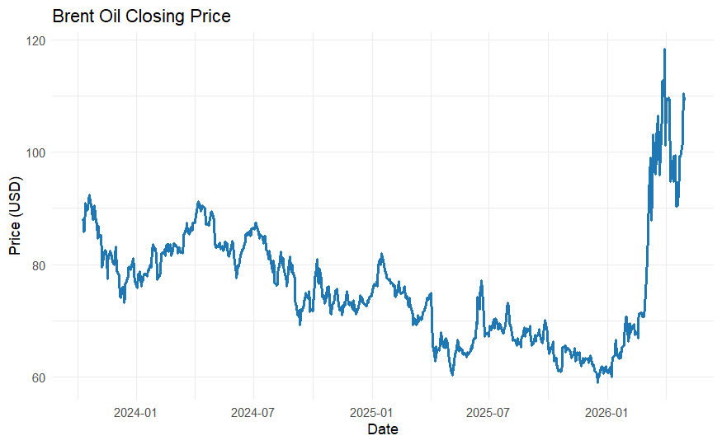
- Time Series Plot of Brent Oil Closing Price
Fig. 1 shows the Brent crude oil price trend from 2023 to 2026. During 2023–2025, prices generally followed a downward trend, declining from around USD 90 to below USD 70 per barrel despite several short-term fluctuations. In contrast, 2026 marked a sharp price increase, with Brent oil rising to above USD 110 per barrel before stabilizing at a relatively high level.

Brent Oil Price Distribution
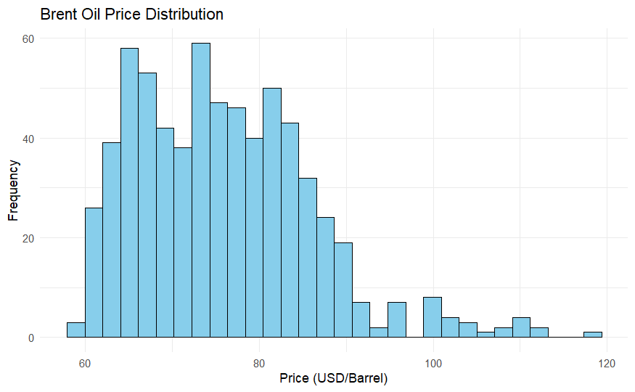
- Histogram of Brent Oil Price
Fig. 2 shows that most Brent oil prices fall within the range of USD 60 to USD 85 per barrel. The histogram is positively skewed, with a few observations exceeding USD 100 per barrel, indicating that high-price events occurred only occasionally during the observation period.

Average Annual Price of Brent Oil
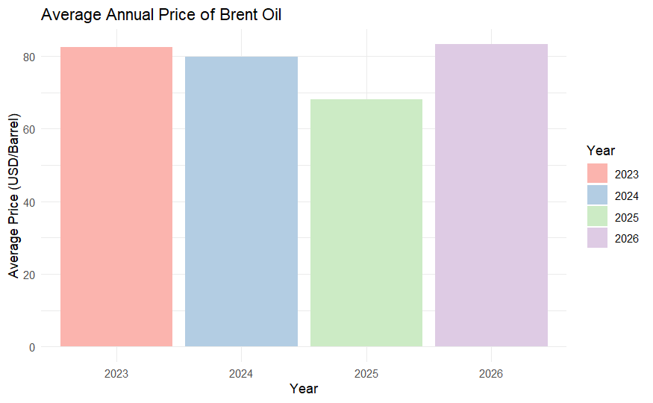
- Barplot of Average Annual Price of Brent Oil (?)
Fig. 3 shows the annual average Brent oil prices from 2023 to 2026. The average price declined from 2023 to 2025, reaching its lowest level in 2025, before increasing significantly in 2026. This pattern indicates that Brent oil prices varied across the observation period in response to changing market conditions and external economic factors.

Outliers Plot
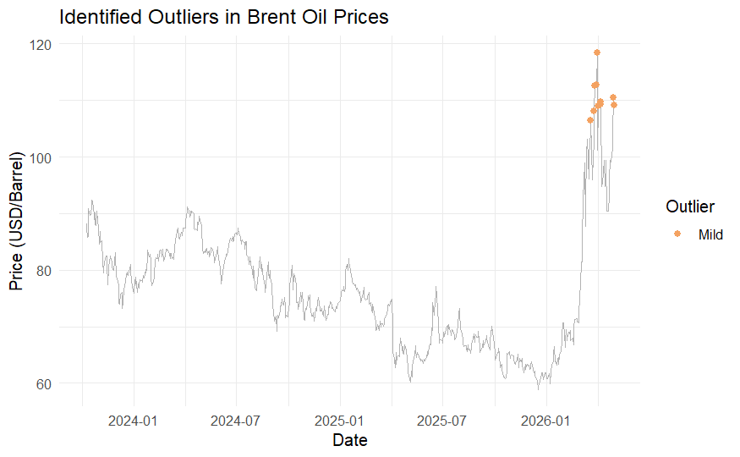
- Outliers Plot in Brent Oil Prices
Fig. 4 shows the outliers in Brent oil prices over the observation period. Most observations are consistent the general price trend, while several mild outliers are detected in early 2026 when prices increased sharply above USD 100 per barrel. These outliers indicate unusual price movements that differ from the overall pattern, reflecting periods of higher price volatility.

Data Preprocessing and Split Data
In this study, several preprocessing steps were conducted before applying the time series forecasting models. These steps included sorting the dataset based on chronological order and checking for missing values. After completing the preprocessing stage, the dataset was divided into training and testing sets using an 80:20 ratio. The split was performed chronologically to preserve the temporal dependency inherent in the time series data.
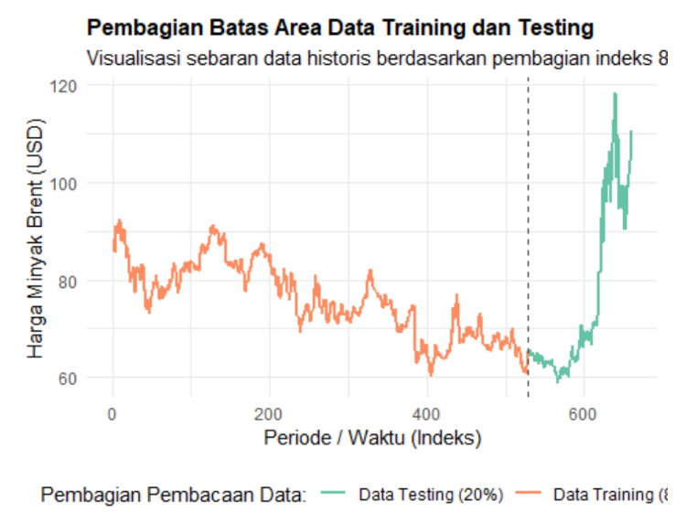
- Splitting Data Plot
The training data consist of 528 data that contains the data from 9 October 2023 until 22 October 2025. The remainder is data that will be used as testing data, amounting to 128 data, namely from October 23, 2025 to April 30, 2026. The data splitting visualization is shown in Figure 5.

Stationarity Testing

Stationarity Testing to Variance
- Result of Power Transformation
 | LRT | df | p-value
LR test, lambda = (1) | 0. 3886813 | 1 | 0. 53299
As presented in Table I, the p-value derived from the stationarity test is 0.53299, which exceeds the 0.05 significance threshold. Consequently, the null hypothesis cannot be rejected, indicating that the series exhibits variance stationarity and requires no further transformation.

Stationarity Testing to Mean
- Result of ADF Test
 | Dickey-fuller | Lag Order | p-value
train_data | -3.2225 | 8 | 0.08405
Based on Table II, the p-value obtained from the stationarity test is 0.08405, which is greater than the significance level of 0.05. Therefore, we failed to reject$H_{0}$, showing that the data is not stationary to mean. Therefore, differencing the data is required to achieve stationarity before proceeding with the forecasting analysis.
- Result of Differencing
 | Dickey-fuller | Lag Order | p-value
train_data | -9.8386 | 8 | 0.01
Based on Table III, the p-value obtained from the stationarity test is 0.01, which is less than the significance level of 0.05. Therefore, we reject H0, showing that the data is already stationary to mean. This means that the data is ready to be used because it meets the stationarity assumption.

Forecasting Results

Naïve Trend
- Result of Naïve Trend Forecasting
 | Test RMSE | TEST MAE | Test MAPE
Naïve | 20.0724 | 12.8769 | 13.8413
Based on Table IV, the Naïve forecasting model produced a testing a RMSE of 20.0724, MAE of 12.8769, and a MAPE of 13.8413%. Based on the MAPE value indicates that the forecasts differed from the actual values by an average of 13.84%, which can be categorized as good forecasting performance. However, further comparison with other forecasting methods is required to determine the most accurate model.
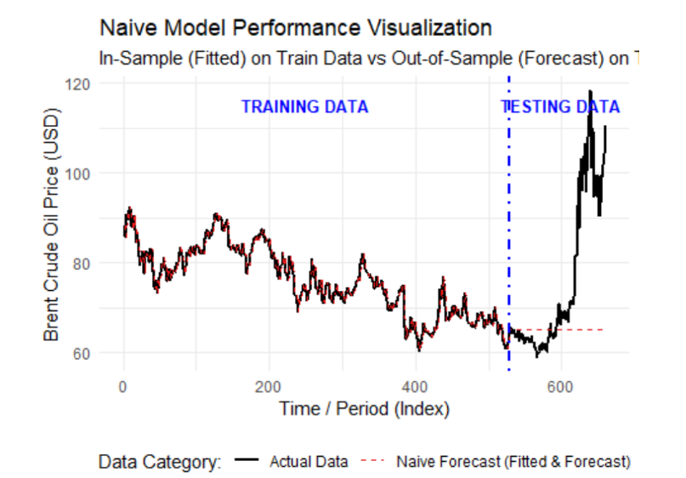
- Naïve Model Performance Visualization
The performance of the baseline Naive model for Brent Crude Oil Price forecasting is presented in Figure 6. In the in-sample period, the fitted naive values closely mimic the historical actual data. Conversely, the out-of-sample forecast on the testing data remains perfectly flat, failing to anticipate the dramatic price surge observed after index 600. This outcome demonstrates that while a naive model can serve as a simple benchmark, its assumption of static future values renders it highly inadequate for volatile commodities like crude oil, thereby justifying the development of advanced predictive frameworks.

Double Moving Average
- Result of Double Moving Average Forecasting
n | Test RMSE | Test MAE | Test MAPE
3 | 66.6278 | 60.1959 | 77.96029
4 | 27.2631 | 24.6788 | 33.5867
6 | 20.6840 | 13.1335 | 13.96762
7 | 32.9181 | 24.3876 | 27.82997
8 | 40.3125 | 31.2094 | 36.38345
As illustrated in Table V, the DMA model attains its peak forecasting performance when configured with a window size of 6. Compared to all other evaluated parameter intervals, this specific window size minimized the testing errors, yielding the lowest RMSE, MAE, and MAPE values at 20.6840, 13.1335, and 13.97%, respectively. Consequently, a window size of 6 was established as the optimal parameter configuration for the DMA model.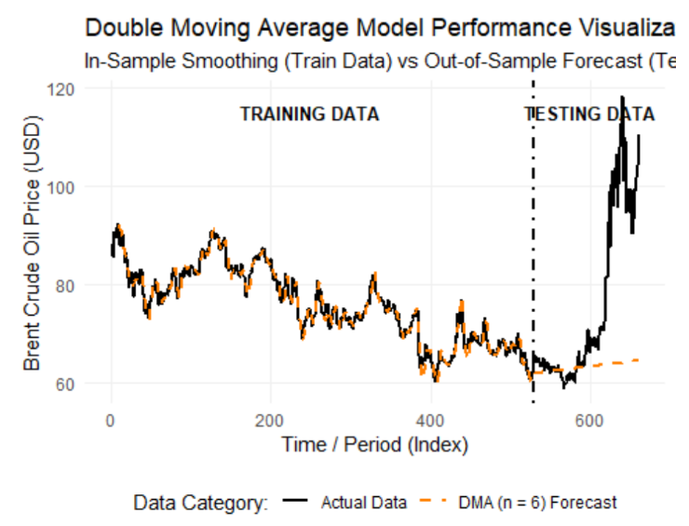
- Double Moving Average Model Performance Visualization
The performance of the Double Moving Average (DMA, $n = 6$) model is shown in Figure 7. During the in-sample training period, the DMA line closely follows the actual Brent Crude Oil price movements, successfully filtering out minor noise. In the out-of-sample testing partition, the model projects a conservative, marginally upward-sloping linear trend. While this represents a slight theoretical advancement over static baseline models, it completely fails to anticipate the aggressive, exponential upward momentum observed after period 600. This outcome reinforces the limitation of moving average variants when applied to highly volatile financial time series characterized by sudden regime shifts.

Double Exponential Smoothing
- Result of Double Exponential Smoothing Forecasting
$$α$$ | $$β$$ | Test RMSE | Test MAE | Test MAPE
0.16 | 0.081 | 10.4854 | 8.9371 | 11.8643
0.17 | 0.083 | 10.5162 | 8.9909 | 12.0513
0.29 | 0.094 | 10.7681 | 9.2584 | 12.4240
0.33 | 0.095 | 10.8418 | 9.3268 | 12.4448
0.33 | 0.097 | 10.8842 | 9.3899 | 12.7726
Based on Table VI, the DES model achieves its best forecasting performance with a smoothing parameter of $α$ = 0.16 and a trend parameter of $β$ = 0.081. Among all parameter combinations tested, this configuration produces the lowest testing RMSE, MAE, and MAPE values of 10.4854, 8.9371, and 11.86%, respectively. Therefore, $α$ = 0.16 and $β$ = 0.081 were selected as the optimal parameters for the DES model.
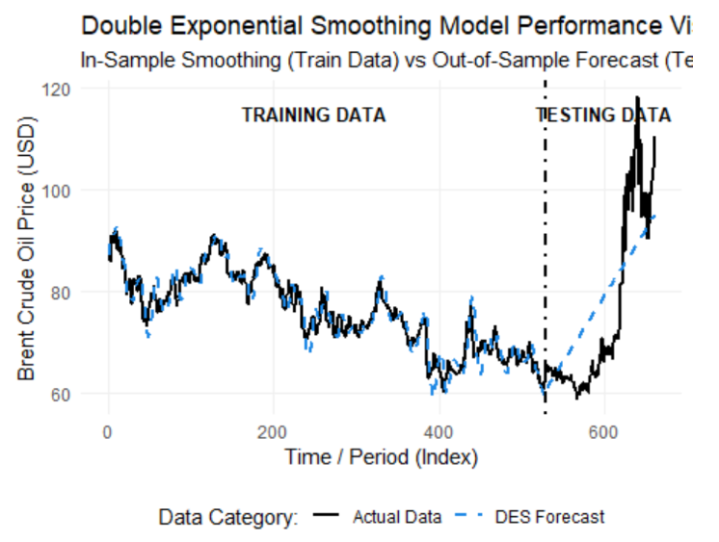
- Double Exponential Smoothing Model Performance Visualization
The performance of the Double Exponential Smoothing (DES) model is illustrated in Figure 8. During the in-sample training period, the DES forecast exhibits an excellent smoothing fit that closely follows historical price variations. In the out-of-sample testing phase, the model generates a strong, linearly increasing trend projection. Although this linear projection temporarily overestimates prices during the initial stagnation phase (periods 530 to 600), it successfully captures the broader upward macroeconomic momentum that follows, culminating in a final forecast value close to the actual terminal price. This behavior confirms that incorporating exponential trend smoothing significantly improves directional accuracy compared to static baselines, even though it remains constrained by a constant linear growth rate.

Time Series Regression
- Result of Time Series Regression Forecasting
Type | p-value |  | Test RMSE | Test MAE | Test MAPE
 | Normality | Homoskedasticity
Trend | 0.281 | 2.346 $×$ 10^{-10*} | 22.7445 | 14.5532 | 15.532
Trend + Lag 1 | 0.0023* | 0.4701 | 22.3609 | 14.3295 | 15.3180
Trend + Lag 1 + Lag 9 | 0.0023* | 0.1974 | 22.3558 | 14.2776 | 15.2353
Lag 1 | 0.0238* | 0.3957 | 16.7437 | 11.9715 | 13.7665
Lag 9 | 0.3275 | 0.9235 | 17.3762 | 11.4167 | 12.5389
Note: * means doesn’t satisfy the assumption of normality or homoskedasticity
Based on Table VII, the time series regression model with Lag 9 achieves the best overall forecasting performance. This model satisfies both the normality and homoskedasticity assumptions, as indicated by p-values of 0.3275 and 0.9235, respectively, which are greater than the significance level of 0.05. Furthermore, it produces the lowest testing MAE and MAPE values of 11.4167 and 12.54%, respectively, among all model specifications evaluated. Therefore, the Lag 9 model was selected as the optimal time series regression model for forecasting Brent crude oil prices.
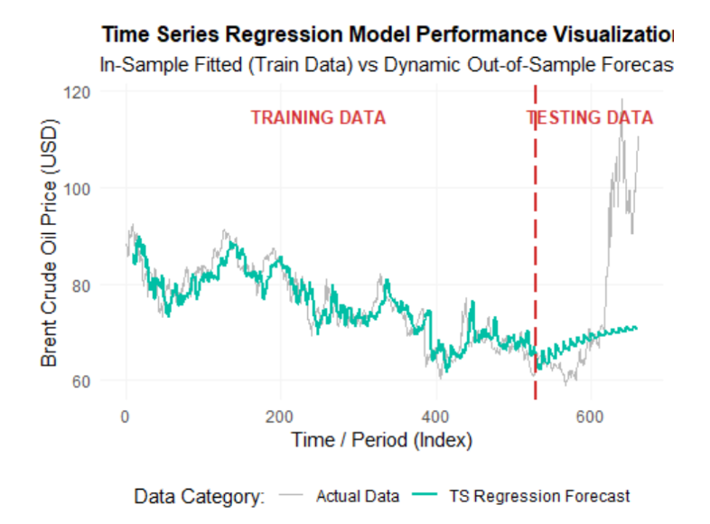
- Time Series Regression Model Performance Visualization
The performance of the Time Series Regression model is illustrated in Figure 9. In the training data phase, the model provides a generalized fit that captures the primary underlying downward trend while filtering out localized market noise. In the out-of-sample testing phase, the dynamic forecast generates an oscillating, linearly increasing trend trajectory. Although this green forecast path captures the initial structural turning point and tracks the actual prices moderately well up to period 600, it proves entirely inadequate for capturing the extreme exponential price acceleration observed in the final periods. This outcome emphasizes the limitation of traditional deterministic regression models when confronting regime shifts and high-volatility shocks inherent to global commodity pricing.

ARIMA
- Result of ARIMA Forecasting
Type | Parameter Significance | p-value |  | Test MAE | Test MAPE | Test RMSE
 |  | Normality | White Noise
ARIMA (0,1,1) | No | 0.0028* | 0.976 | 20.076 | 12.878 | 13.841
ARIMA (0,1,2) | No | 0.00538* | 0.928 | 19.962 | 12.860 | 13.861
ARIMA (0,1,3) | No | 0.0172* | 0.993 | 20.162 | 12.890 | 13.826
ARIMA (1,1,0) | No | 0.0028* | 0.98 | 20.077 | 12.878 | 13.841
ARIMA (1,1,1) | No | 0.0037* | 0.877 | 20.065 | 12.876 | 13.843
ARIMA (1,1,2) | No | 0.0142* | 0.988 | 20.049 | 12.873 | 13.845
ARIMA (2,1,0) | No | 0.0069* | 0.967 | 19.972 | 12.861 | 13.852
ARIMA (2,1,1) | No | 0.0051* | 0.996 | 20.002 | 12.866 | 13.852
ARIMA (2,1,2) | Yes | 0.0002* | 0.842 | 20.116 | 12.886 | 13.838
ARIMA (2,1,3) | No | 0.0005* | 0.963 | 20.099 | 12.881 | 13.836
ARIMA (3,1,0) | No | 0.0152* | 0.943 | 20.126 | 12.884 | 13.831
ARIMA (3,1,3) | No | 0.0009* | 0.707 | 20.105 | 12.882 | 12.836
Note: * means doesn’t satisfy the assumption of normality
As presented in Table VIII, the ARIMA(2,1,2) model delivers satisfactory forecasting performance, yielding testing RMSE, MAE, and MAPE values of 20.1157, 12.8859, and 13.84%, respectively. All estimated parameters are statistically significant, and the diagnostic checks confirm that the residuals conform to the white noise assumption, evidenced by a p-value of 0.8423. Conversely, the residuals violate the normality assumptio $p\text{-value}=0.002251<0.05$. Notwithstanding this non-normality constraint, the ARIMA(2,1,2) framework remains robust enough to generate reasonably precise projections, maintaining a low average percentage error of 13.84%.
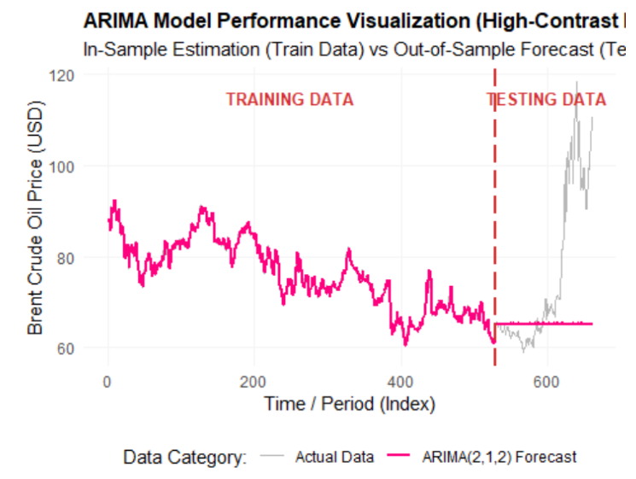
- ARIMA(2,1,2) Model Performance Visualization
The performance of the ARIMA(2,1,2) model for Brent Crude Oil Price forecasting is detailed in Figure 10. While the in-sample training estimation demonstrates a near-perfect tracking of historical price movements, the out-of-sample forecast degrades into a flatline projection. This flat horizontal pattern highlights a classic constraint of ARIMA modeling: without an explicit, deterministic long-term drift or non-linear adjustments, the forecast reverts to a constant baseline over extended horizons. As a result, the model is completely blindsided by the dramatic exponential price breakout observed post-index 600, emphasizing the necessity of migrating toward non-linear machine learning or deep learning frameworks for dynamic commodity markets.

Multi-Layer Perceptron
- Result of Multi-Layer Perceptron Forecasting
Model | Hidden Unit | Test RMSE | Test MAE | Test MAPE
A | 128 | 4.218 | 2.875 | 3.26
B | 150 | 4.450 | 2.983 | 3.39
C | 100, 50 | 4.729 | 3.261 | 3.72
D | 128, 64 | 3.988 | 2.780 | 3.26
E | 150, 100 | 4.519 | 2.838 | 3.26
F | 128, 64,32 | 5.936 | 4.244 | 4.91
G | 150, 100, 50 | 4.845 | 3.450 | 4.05
Based on Table IX, Model D with 128 and 64 hidden units achieves the best forecasting performance among all MLP architectures evaluated. This model produces the lowest testing RMSE and MAE values of 3.988 and 2.780, respectively, while achieving a MAPE of 3.26%. Therefore, Model D was selected as the optimal MLP architecture for forecasting Brent crude oil prices.
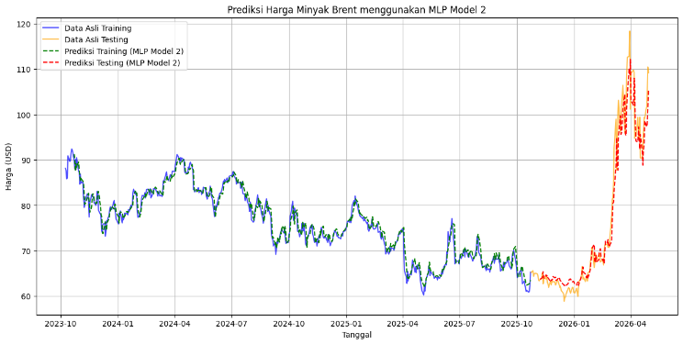
- MLP Model Performance Visualization
The in-sample and out-of-sample performance of the Multilayer Perceptron (MLP Model 2) for Brent Crude Oil Price forecasting is illustrated in Figure 11. During the training sequence, the model's predictions (dashed green line) fit the historical data near-perfectly. Unlike the rigid linear projections or flatlines observed in the benchmark models, the out-of-sample testing prediction (dashed red line) remarkably tracks the actual exponential market breakout post-January 2026, including the steep escalation above 110 USD and the subsequent volatile fluctuations. This outcome validates the implementation of MLP architectures for financial time series forecasting, proving its robust capability to model high-volatility regimes and sudden macroeconomic shocks in the energy sector.

Long Short-Term Memory
- Result of Long Short-Term Memory Forecasting
Model | Layers | Hidden Unit | Test RMSE | Test MAE | Test MAPE
A | 1 | 50 | 4.929 | 3.268 | 3.71
B | 1 | 100 | 3.964 | 2.630 | 3.07
C | 1 | 128 | 3.975 | 2.675 | 3.16
D | 2 | 50, 50 | 4.605 | 3.061 | 3.53
E | 2 | 100, 50 | 4.182 | 2.775 | 3.21
F | 2 | 128, 64 | 3.840 | 2.682 | 3.21
G | 3 | 100, 50, 25 | 5.168 | 3.407 | 3.87
H | 3 | 128, 64, 32 | 4.591 | 3.082 | 3.60
Based on Table X, model B with a single LSTM layer and 100 hidden units achieves the best forecasting performance among all LSTM architectures evaluated. This model produces the lowest testing MAE and MAPE values of 2.630 and 3.07%, respectively, while achieving a testing RMSE of 3.964. Therefore, Model B was selected as the optimal LSTM architecture for forecasting Brent crude oil prices.
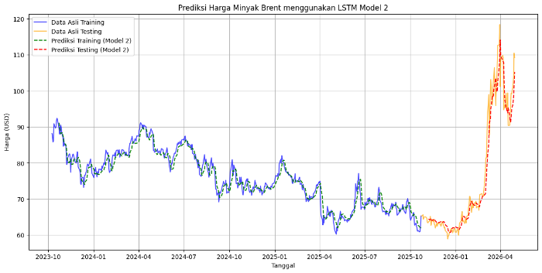
- LSTM Model Performance Visualization
The in-sample and out-of-sample performance of the LSTM Model 2 for Brent Crude Oil Price forecasting is presented in Figure 12. The model exhibits a highly precise fit during the training phase, successfully capturing historical patterns. In the out-of-sample testing window, the LSTM model (dashed red line) delivers an outstanding performance by closely mirroring the actual market dynamics (orange line). It exceptionally tracks both the massive exponential trend expansion exceeding 110 USD in early 2026 and the highly volatile fluctuating behavior immediately following the peak. This robust forecasting accuracy confirms the superiority of recurrent neural network architectures, particularly LSTM, in preserving long-term dependencies and adjusting to sharp structural breaks within complex time series data.

Gated Recurrent Unit
- Result of Gated Recurrent Unit Forecasting
Model | Layers | Hidden Unit | Test RMSE | Test MAE | Test MAPE
A | 1 | 50 | 3.904 | 2.647 | 3.01
B | 1 | 100 | 3.623 | 2.393 | 2.83
C | 1 | 128 | 3.708 | 2.435 | 2.83
D | 2 | 50, 50 | 3.807 | 2.567 | 2.94
E | 2 | 100, 50 | 3.941 | 2.651 | 3.01
F | 2 | 128, 64 | 3.704 | 2.325 | 2.70
G | 3 | 100, 50, 25 | 3.542 | 2.298 | 2.74
H | 3 | 128, 64, 32 | 3.837 | 2.518 | 2.90
Based on Table XI, model F with two GRU layers and 128 and 64 hidden units achieves the best forecasting performance among all GRU architectures evaluated. This model produces the lowest testing MAE and MAPE values of 2.325 and 2.70%, respectively, while achieving a testing RMSE of 3.704. Therefore, Model F was selected as the optimal GRU architecture for forecasting Brent crude oil prices.
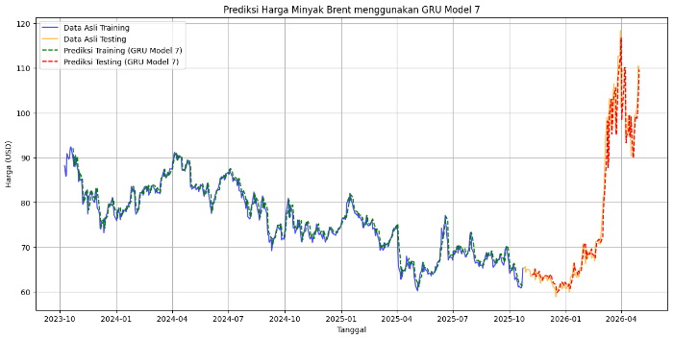
- GRU Model Performance Visualization
The performance of the GRU Model 7 for Brent Crude Oil Price forecasting is illustrated in Figure 13. The model achieves an optimal in-sample fit over the training set, successfully mirroring historical cyclical trends. In the out-of-sample testing sequence, the GRU network (dashed red line) delivers highly superior predictive accuracy by virtually overlaying the actual price action (orange line). It exceptionally models the aggressive exponential market acceleration exceeding 110 USD in early 2026 and perfectly handles the complex, volatile structural shifts immediately following the market peak. This underscores the robustness of gated recurrent networks in adapting to severe macroeconomic energy shocks and capturing complex temporal patterns in highly volatile financial environments.

Comparison of Forecasting Models
- Comparison of Forecasting Models
Model | Test RMSE | Test MAE | Test MAPE
Naïve Trend | 20.0724 | 12.8769 | 13.8413
DMA (n = 6) | 20.6840 | 13.1335 | 13.9676
DES ($α=0.16, β=0.081$) | 10.4854 | 8.9371 | 11.8643
Time Series Regression (Lag 9) | 17.3762 | 11.4167 | 12.5389
ARIMA(2,1,2) | 20.1157 | 12.8859 | 13.8377
MLP (D) | 3.988 | 2.780 | 3.26
LSTM (B) | 3.964 | 2.630 | 3.07
GRU (F) | 3.704 | 2.325 | 2.70
Based on Table XII, the machine learning models consistently outperform the traditional forecasting models across all evaluation metrics. The GRU model recorded the lowest testing RMSE of 3.704, MAE of 2.325, and MAPE of 2.70%, making it the best forecasting performance among all evaluated models.
Meanwhile, the traditional models, including Naïve Trend, DMA, DES, Time Series Regression, and ARIMA, resulted in higher forecasting errors. Among these models, DES provided the best performance, with a testing RMSE of 10.4854, MAE of 8.9371, and MAPE of 11.8643. Overall, these results indicate that machine learning models are more effective in capturing the complex patterns of Brent oil prices, leading to more accurate forecasts than traditional methods.

Conclusion
During the observation period, Brent crude oil prices exhibited severe volatility, structural breaks, and a dramatic, non-linear exponential upward surge in the testing phase, while statistical diagnostics revealed that the underlying time series data was highly non-stationary and non-normally distributed. To capture these complex temporal patterns, this study evaluated a spectrum of forecasting frameworks, where visual and empirical comparisons highlighted a distinct performance divide between traditional statistical methods and deep learning architectures.
The empirical visualizations highlight contrasting behavior between traditional and advanced models during the out-of-sample period. While the baseline Naïve (Figure 6) and ARIMA (Figure 10) models entirely flatlined, the Double Moving Average (Figure 7) produced a heavily delayed and severely underestimated linear path. Similarly, both the Double Exponential Smoothing (Figure 8) and Time Series Regression (Figure 9) frameworks were bounded by rigid, deterministic structures that failed to capture the market's explosive momentum. In contrast, the machine learning and deep learning architectures displayed exceptional responsiveness to the market shock. The Multi-Layer Perceptron (Figure 11) and Long Short-Term Memory (Figure 12) networks effectively traced the non-linear price surge, whereas the Gated Recurrent Unit (GRU Model 7, Figure 13) yielded the most optimal forecasting performance, aligning seamlessly with the abrupt exponential breakout and the ensuing highly volatile structural corrections.
Specifically, the optimal GRU architecture configured with two hidden layers of 128 and 64 units minimized empirical errors to a testing RMSE of 3.704, MAE of 2.325, and MAPE of 2.70%, proving that its internal gating mechanisms capture high-dimensional non-linear dependencies far more effectively than classical benchmarks. Despite these promising results, the persistent non-normality of the commodity data poses structural constraints on assumption-based models, suggesting that future research should explore alternative preprocessing techniques or incorporate exogenous macroeconomic and geopolitical indicators to further refine forecasting accuracy under extreme market uncertainty.

Acknowledgment
We would like to express our profound gratitude to our lecturer, Syarifah Diana Permai, S.Si., M.Si., for her invaluable guidance, continuous support, and encouragement throughout this research. Her academic expertise and unwavering dedication were instrumental to the successful completion of this study.

References

[1] | R. Amelia and L. A. Wulandhari, "Crude Oil Price Forecasting Using LSTM and GRU Feature Extractor and Machine Learning Regressor," Journal of Advances in Information Technology, vol. 16, no. 8, pp. 1100-1117, 2025.
[2] | T. Krulicky, A. Jura and R. Kunju Mol Raj, "Navigating the Dynamics of Brent Crude Oil Prices: Factors, Trends, and Insights," Acta Monstanistica Slovaca, vol. 29, no. 1, pp. 86-102, 2024.
[3] | V. D. Pangestika, Farikhin and T. Udjiani, "Application of the geometric Brownian motion model in West Texas Intermediate crude oil price prediction," Gema Wiralodra, vol. 14, no. 3, pp. 1061-1068, 2023.
[4] | T. E. Yilmaz and C. Zehir, "Strategic Risk Based Forecasting of Brent Crude Oil Prices: A Comparative Analysis of Econometric and Machine Learning Models," Entropy, vol. 28, no. 5, pp. 1-27, 2026.
[5] | L. Guo, X. Huang, Y. Li and H. Li, "Forecasting crude oil futures price using machine learning methods: Evidence from China," Energy Economics, vol. 127, 2023.
[6] | H. Iftikhar, A. Zafar, J. E. Turpo-Chaparro, P. C. Rodrigues and J. L. Lopez-Gonzales, "Forecasting Day-Ahead Brent Crude Oil Prices Using Hybrid Combinations of Time Series Models," Mathematics, vol. 11, pp. 1-19, 2023.
[7] | A. L. Zahouani and H. Boubaker, "Forecasting Crude Oil Price with Hybrid Approaches," Review of Economics and Finance, vol. 21, no. 1, pp. 564-576, 2023.
[8] | L. Schmid, M. Roidl, A. Kirchherim and M. Pauly, "Comparing Statistical and Machine Learning Methods for Time Series Forecasting in Data-Driven Logistics—A Simulation Study," Entropy, vol. 27, pp. 1-38, 2025.
[9] | H. Fatima, B. Tahir and K. Hamid, "Hybrid ARIMA and LSTM Deep Learning Models Empowering and Enhancing Forecast Accuracy in Sales," Spectrum of Engineering Sciences, vol. 3, no. 9, pp. 117-133, 2025.
[10] | A. Lazcano, M. A. Jaramillo-Moran and J. E. Sandubete, "Back to Basics: The Power of the Multilayer Perceptron in Financial Time Series Forecasting," Mathematics, vol. 12, no. 12, 2024.
[11] | A. Pranolo, X. Zhou and Y. Mao, "Time Series Forecasting with LSTM: an extensive content analysis," Knowledge Engineering and Data Science, vol. 8, no. 1, pp. 16-50, 2025.
[12] | O. E. Arokodare and J. Kim, "Leveraging Machine Learning for Enhanced Predictive Accuracy in Time Series Forecasting: A Comparative Analysis of LSTM and GRU Models," pp. 1-8, 2024.
[13] | M. As'ad, E. Yuniar, Sujito, E. Farida and S. Setyowibowo, "PeramalanHarga Crude Oildengan Model Double Exponensial Smoothing-Holts," G-Tech : Jurnal Teknologi Terapan, vol. 7, no. 1, pp. 201-208, 2023.
[14] | Y. Gampar and N. Agustina, "orecasting Oil And Gas Production in Indonesia: A Comparison of Holt’s Double Exponential Smoothing and ARIMA Methods," Seminar Nasional Official Statistics, vol. 1, pp. 211-220, 2024.
[15] | A. Daneshvar, M. Ebrahimi, F. Salahi, M. Rahmaty and M. Homayounfar, "Brent Crude Oil Price Forecast Utilizing Deep Neural Network Architectures," Computational intelligence and neuroscience, pp. 1-13, 2022.
[16] | M. Alruqimi and L. D. Persio, "Enhancing Multi-step Brent Oil Price Forecasting with Ensemble Multi-scenario Bi-GRU Networks," International Journal of Computational Intelligence Systems, pp. 1-12, 2024.
[17] | M. Brown, E. Chen, S. Lee, J. Taylor, A. Kim and R. Johnson, "Comparative Analysis of LSTM and Traditional Time Series Models on Oil Price Data," Preprints, 2024.
[18] | S. A. F. Mortezanejad and R. Wang, "Addressing Challenges in Time Series Forecasting: A Comprehensive Comparison of Machine Learning Techniques".
[19] | T. C. Akinci and A. A. Martinez-Morales, "Why Model Selection Fails in Time Series Forecasting: An Empirical Study of Instability Across Data Regimes," 2026.
[20] | E. Theodorou, E. Spiliotis and V. Assimakopoulos, "Forecast accuracy and inventory performance: Insights on their relationship from the M5 competition data," European Journal of Operational Research, vol. 322, no. 2, pp. 414-426, 2025.
[21] | Y. N. Hilal, G. D. A. Nainggolan, S. H. Syahputri and F. Kartiasih, "Comparison of ARIMA and LSTM Methods in Predicting Jakarta Sea Level," Jurnal Ilmu dan Teknologi Kelautan Tropis, vol. 16, no. 2, pp. 163-178, 2024.
[22] | Investing.com, "Data Historis Minyak Mentah WTI Berjangka," [Online]. Available: https://id.investing.com/commodities/crude-oil-historical-data. [Accessed 2026].
[23] | S. Haben, M. Voss and W. Holderbaum, Core Concepts and Methods in Load Forecasting With Applications in Distribution Networks, Cham: Springer.
[24] | R. R. Barry and I. Bernarto, "Spurious Regression Analysis on Time Series Data From Factors Affecting Indonesian Human Development Indexs in 1990-2017," JURNAL ILMIAH MANAJEMEN BISNIS DAN INOVASI UNIVERSITAS SAM RATULANGI (JMBI UNSRAT), vol. 7, no. 3, pp. 592-611, 2020.
[25] | R. J. Hyndman and G. Athanasopoulos, Forecasting Principle and Analysis, Melbourne: OTexts, 2021.
[26] | A. Kumila, B. E. Sholihah, N. Safitri and S. Fitri, "Perbandingan Metode Moving Average dan Metode Naïve Dalam Peramalan Data Kemiskinan," Jurnal Teori dan Aplikasi Matematika (JTAM), vol. 3, no. 1, pp. 65-73, 2019.
[27] | A. Suara, A. Sanjaya and D. P. Pamungkas, "Implementasi Metode Double Moving Average Untuk Prediksi Produksi Sabun," in Seminar Nasional Inovasi Teknologi , Kediri, 2022.
[28] | A. Ostovar, D. D. Davari and M. Dzikuc, "Determinants of Design with Multilayer Perceptron Neural Networks: A Comparison with Logistic Regression," Sustainability, vol. 17, no. 6, 2025.
[29] | H. Khoshvaght, R. R. Permala, A. Razmjon and M. Khiadani, "A critical review on selecting performance evaluation metrics for supervised machine learning models in wastewater quality prediction," Journal of Environmental Chemical Engineering, vol. 13, pp. 1-17, 2025.
[30] | L. S. Ihzaniah, A. Setiawan and R. W. N. Wijaya, "Perbandingan Kinerja Metode Regresi K-Nearest Neighbor dan Metode Regresi Linear Berganda pada Data Boston Housing," JAMBURA JOURNAL OF PROBABILITY AND STATISTICS, vol. 4, no. 1, pp. 18-29, 2023.
[31] | X. Song, L. Deng, H. Wang, Y. Zhang, Y. He and W. Cao, "Deep learning-based time series forecasting," Artificial Intelligence Review, vol. 23, 2025.

